The Typability Index: A tool for measuring and controlling for typing difficulty in text stimuli.

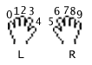**Supplementary Material C. Assumptions for simulating the four typing strategies**

Fingers are numbered according to the right image, from Krzywinski’s Carpalx: <https://mk.bcgsc.ca/carpalx/>. Across all strategies it is assumed that space is typed with a thumb, and is therefore not included in the path length calculations.

**A. Touch typing strategy**

Keys are typed according to the standard touch typing strategy, with four fingers on each hand.

Finger **0 1 2 3 6 7 8 9**

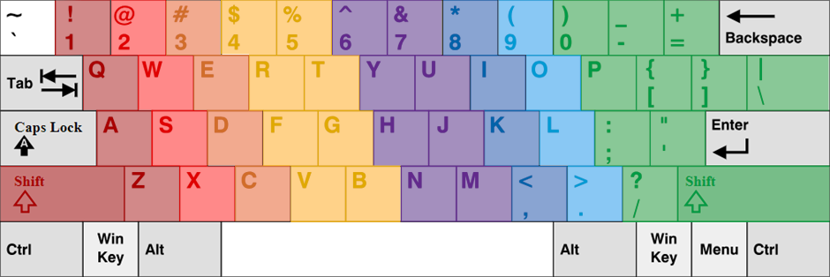

**B. Quad finger strategy**

Keys are typed with the index and middle finger of each hand. A simplified, anecdotal version of the touch typing strategy, where fingers 3 and 6 take up the load of fingers 2 and 3 as indicated above. In addition, fingers 2 and 7 take over from fingers 0 and 1, and 8 and 9 respectively.

Finger **2** **3** **6** **7**

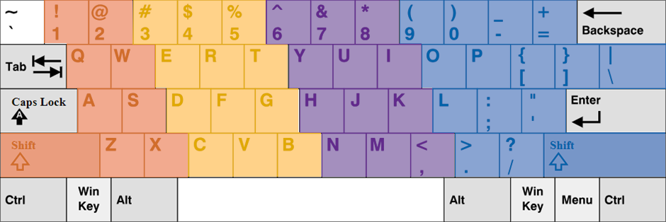

**C. Dual finger strategy**

The keyboard is split in half according to the standard touch typing strategy. One finger on the left hand (e.g. the index) types all the yellow keys, whereas one finger on the right hand types all the purple keys.

Finger **3 6**

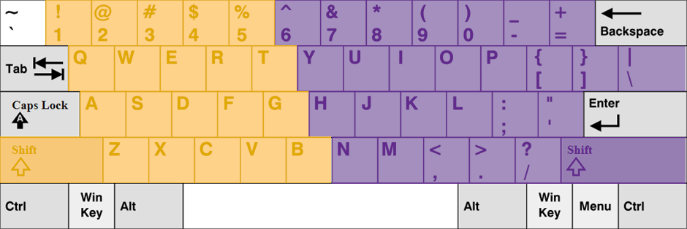

**D. Single finger strategy**

One finger is used to type all keys, e.g. the right index. A finger on another hand is used to hold shift, e.g. the left index.

Finger **3 6**

